ALVA BC6xx Firmware updater V2.10.0

The new FW updater for the ALVA Firmware works also on windows 7 64bits.

There are some issues to know when using the new updater, spo please read this document before updating.

Set the ALVA in FW update mode

We assume you know how to set the ALVA BC6xx in update mode, in the old firmware versions (before 2.8.1) this is an option in the local menu of the ALVA. From Firmware version 2.8.1 and higher you need to press E-ouch buttons 1 and 3 next to the Braille line while switching the ALVA on.
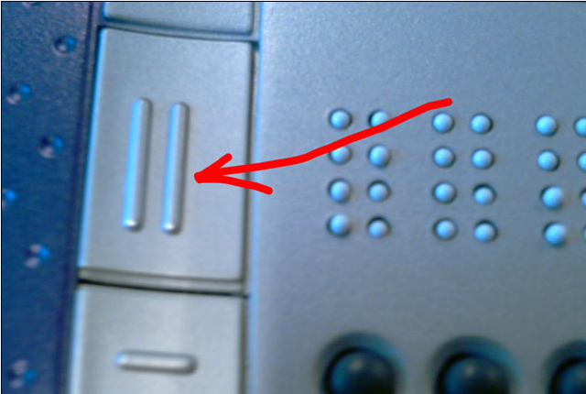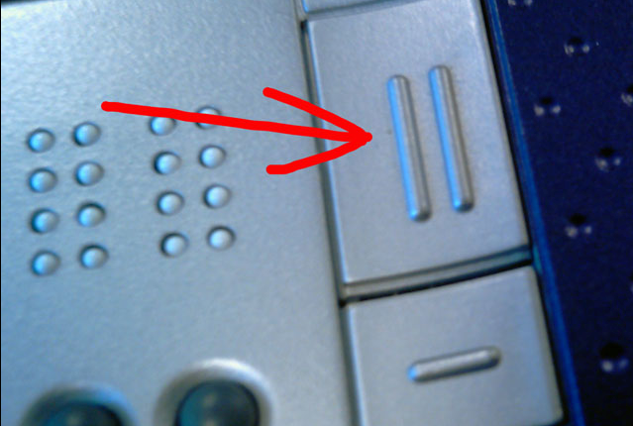

When the ALVA is in update mode DO NOT SWITCH IT OFF !!

If something does not work, disconnect the USB connection to the PC, and reconnect.

USB Device Drivers

As you probably know, if the ALVA is in update mode there should be a different USB device driver installed then in regular ALVA mode. This device was called: “atm6124.Sys ATMEL AT91xxxxxx Test Board”
In this new installer it changed to an USB to serial converter. The new updater does not work with the old device driver, and needs to be updated.

So if you have used an old FW updater on your PC before, most likely it will still install the ALVA’s under the old device driver, and you need to manually change this to the new USB to serial converter.

*So when you see this driver in device manager:
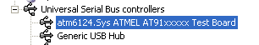

*Select the device, right mouse click, update driver
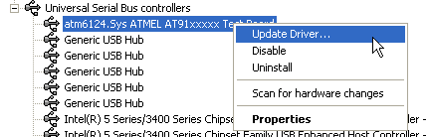

*Do not try via internet (windows update)
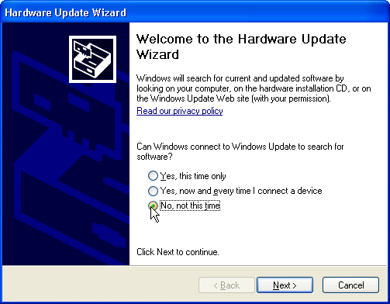

*Select installation from a list
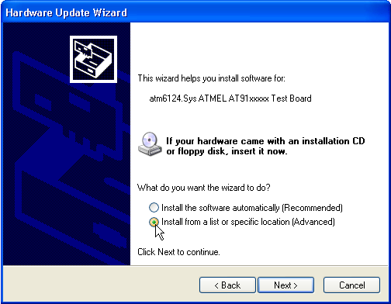

*Then again do not search
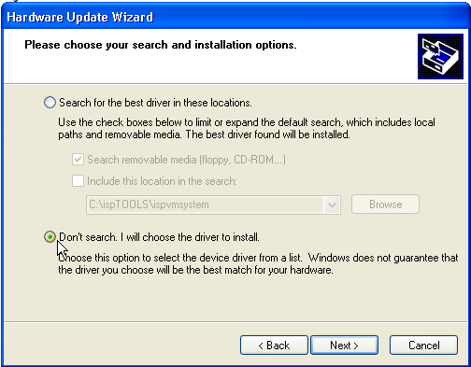

*Select the new AT91 USB to sr4ial converter
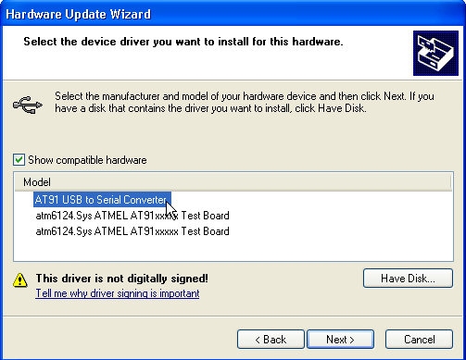

*Now the device should be under “Ports”
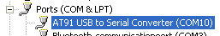

How to know the wrong device driver is installed?

- you can check the Device mangager in Windows
- Or, if the updater stops at this screen and does not continue to the next,
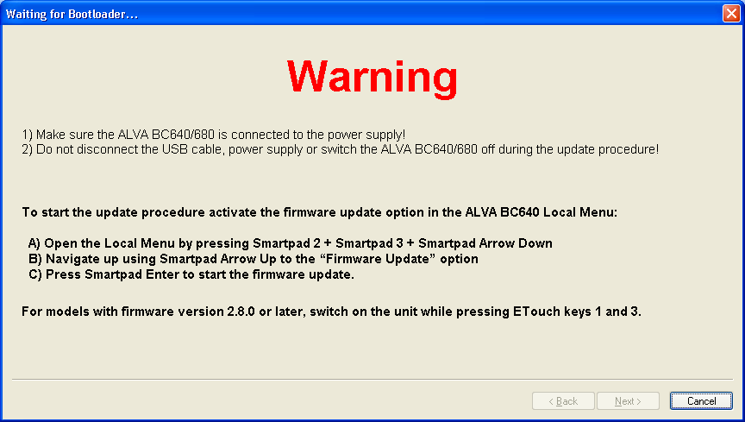

even if the ALVA is connected and in Update mode, probably the wrong device driver is installed

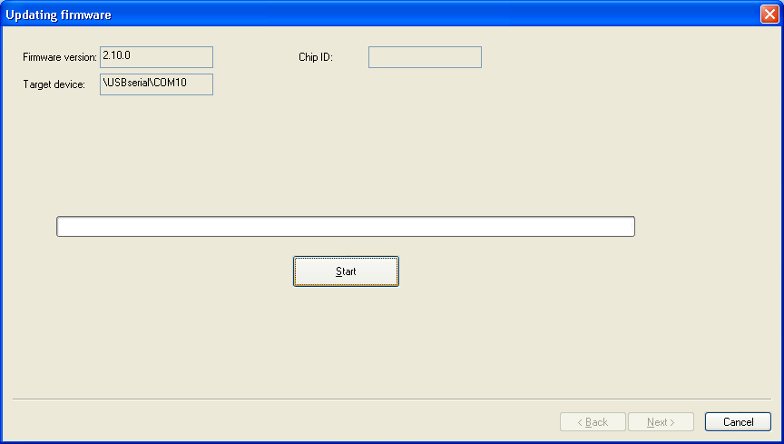

Windows 7-64 bits

In windows 7 the ALVA in update mode will install as “GPS Camera Detect” under Ports. This looks a bit strange, we can not change this because someone registerd the device under this name in Windows 7. But luckily the name does not matter, it will just work as serial port.

